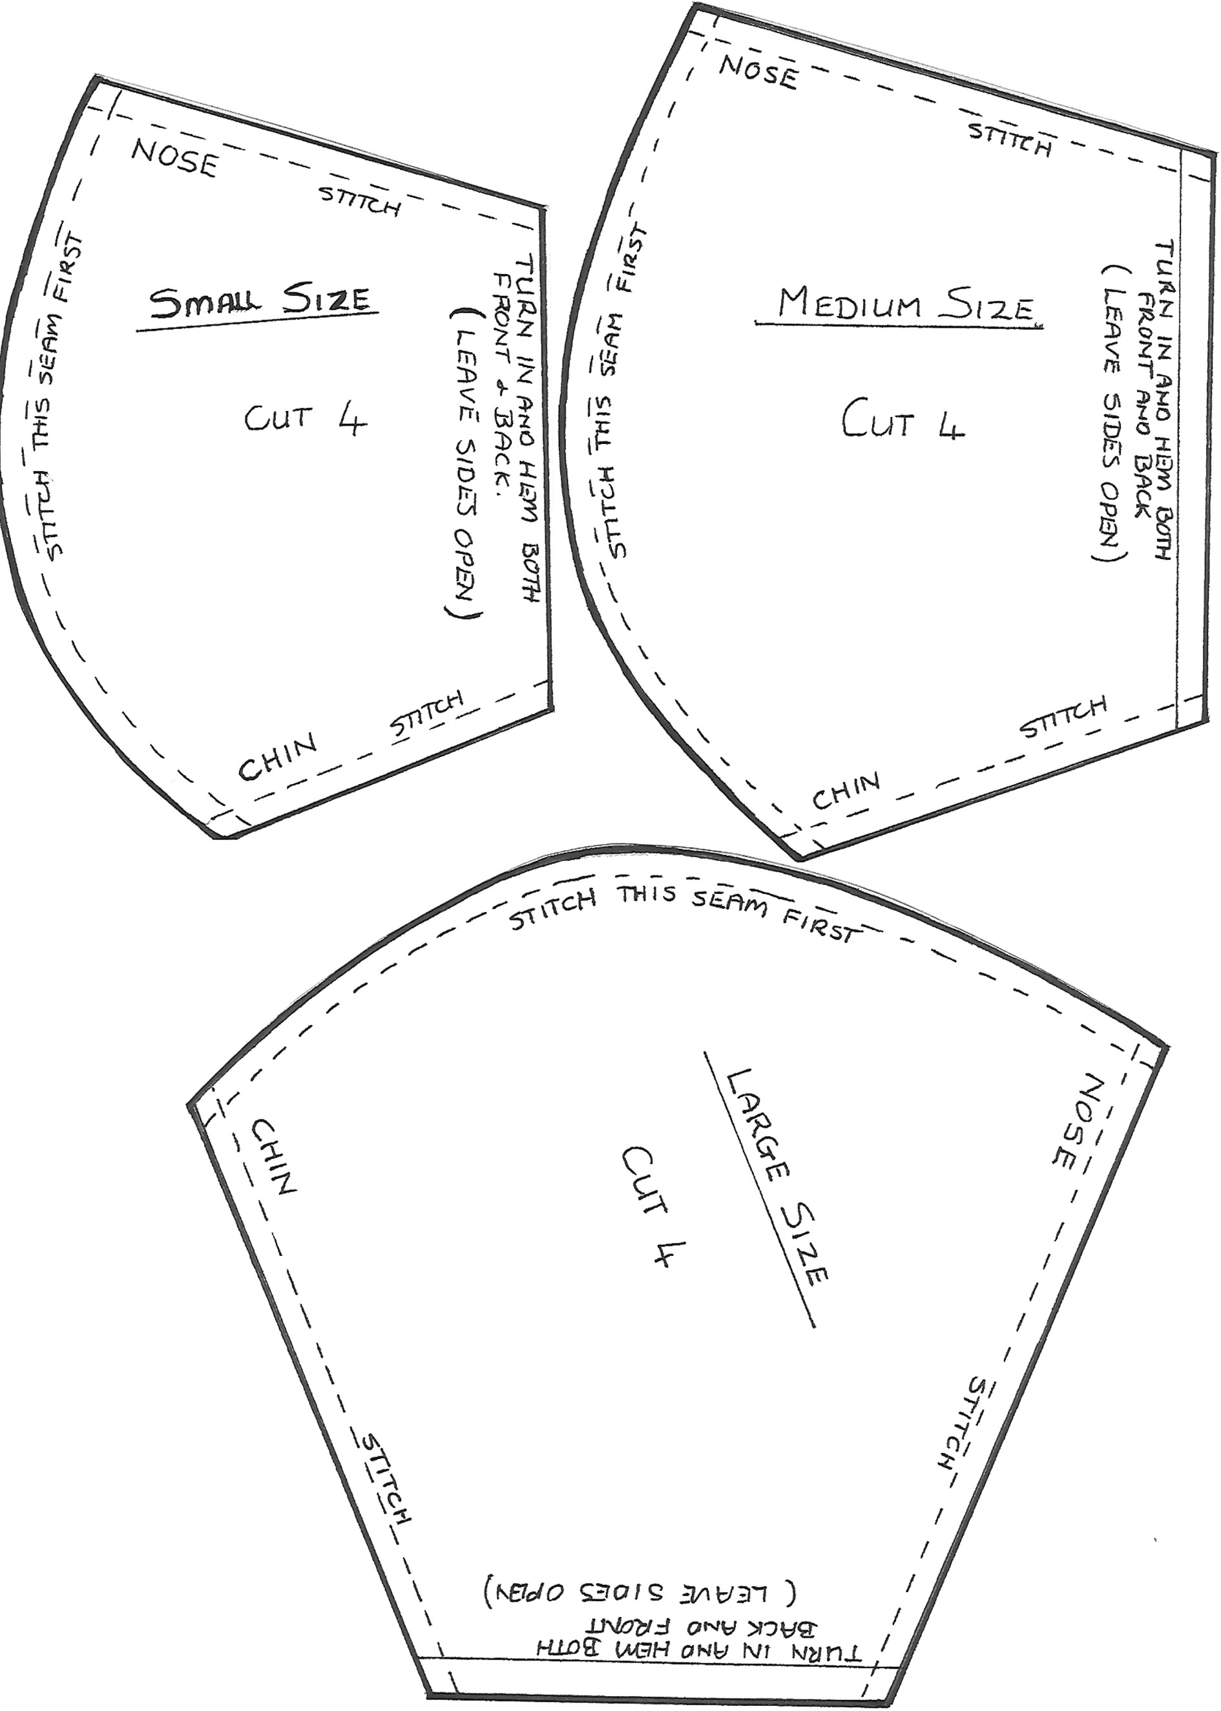

Free Printable:
Presented by youtube.com/fouriefamcam & dadideal.com

